# Simulation and Computing Systems

One of the primary facilities of the AFSL is various software and hardware systems for simulating and validating UAS algorithms and technologies in a laboratory environment.

## Distributed Aircraft Simulators

The Autonomous Flight Systems Laboratory (AFSL) has significant facilities for performing simulation of aircraft dynamics as well as UAS subsystems such as cameras and radios. A distributed simulator (Figure 1) is used to perform verification and validation of control algorithms as well as test human interface systems and perform operator training.

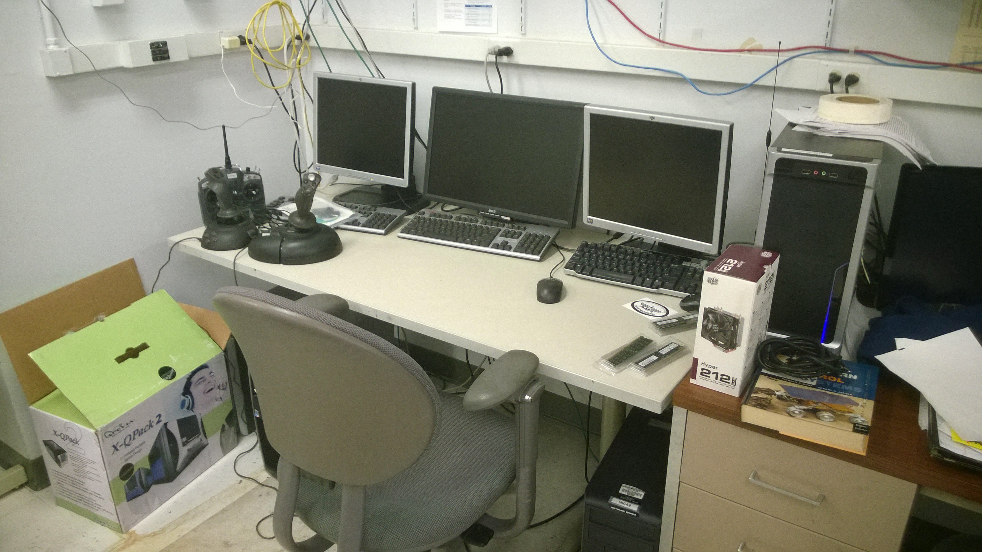

Figure : Distributed simulator system for aircraft dynamics simulation and human interface training.

**ADD INFORMATINO ABOUT THE X-PLANE/MISSION PLANNER SIMULATOR**

## Custom Ground Station Hardware/Software

In addition to simulation capabilities, the AFSL has facilities for developing custom ground stations hardware and software to support new autonomous mission functionality (Figure 2).

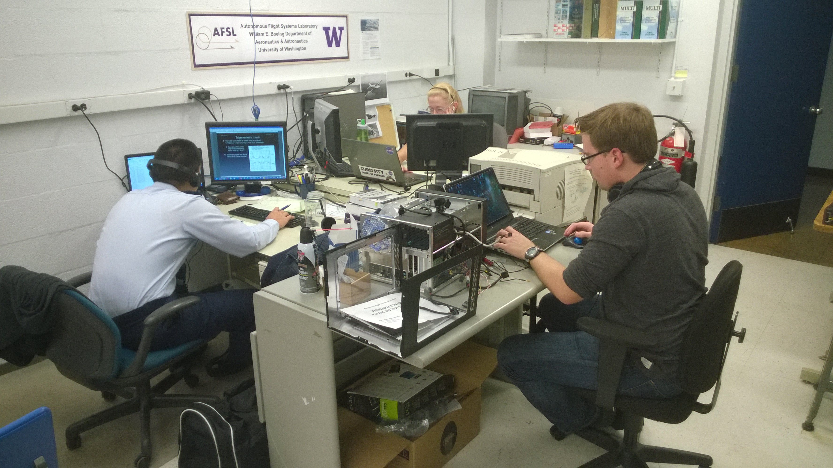

Figure : Simulation and ground station development stations at the AFSL.

## ICOMC2 Development Stations

In addition to developing custom UAS control software/hardware, the AFSL has facilities for developing applications for existing UAS ground station systems such as Insitu’s Common Open-mission Management Command and Control ([ICOMC2](http://www.insitu.com/systems/icomc2)) as shown in Figure 3.

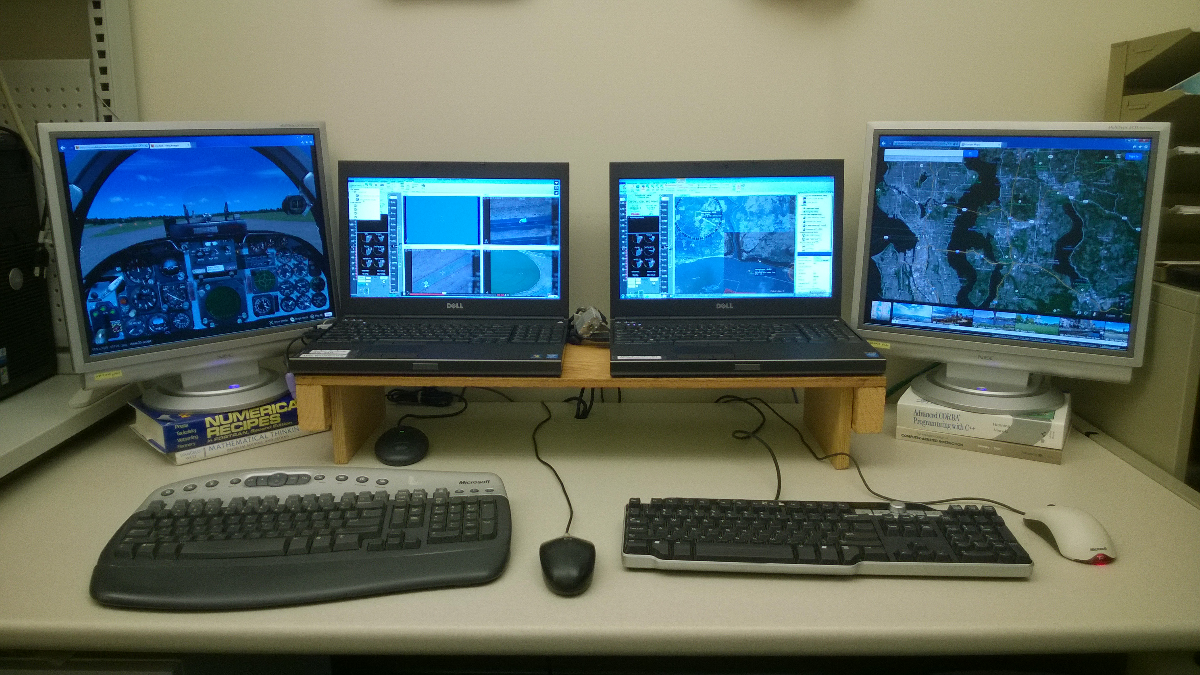

Figure : Two ICOMC2 development and simulation machines are available and are used for developing STANAG-4586 compatible software plug-ins for the ICOMC2 UAS control station system.

# UAS

The AFSL has a hanger of various UAS systems for performing various missions and research.

## Aerosonde

The [Aerosonde](http://en.wikipedia.org/wiki/AAI_Corporation_Aerosonde) was the first UAS to autonomous cross the Atlantic Ocean in 1998. The AFSL was part of this effort and has an Aerosonde airframe for research purposes.

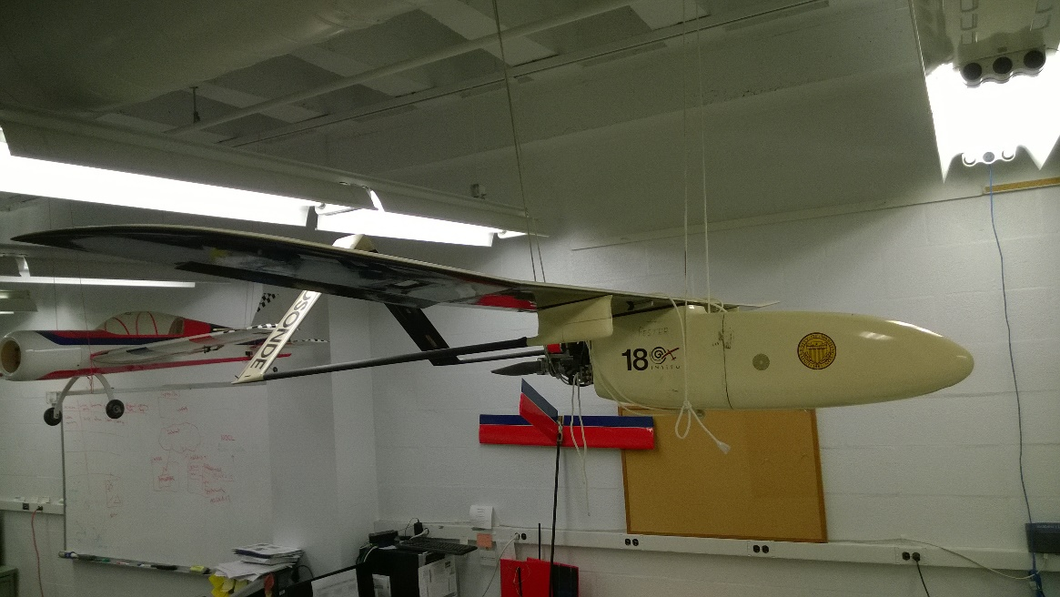

Figure : The AFSL Aerosonde.

## Topography and Ecology Data Drone (TEDD)

The Topography and Ecology Data Drone (TEDD) is a custom build UAS based on a Skywalker 1900 airframe with a modified APM2.6 autopilot. The payload is a Sony Nex-5 camera in a downward facing configuration. The system is used to obtain high-resolution digital imagery of topography and ecology to be used in analysis such as structure-from-motion or digital elevation map generation.

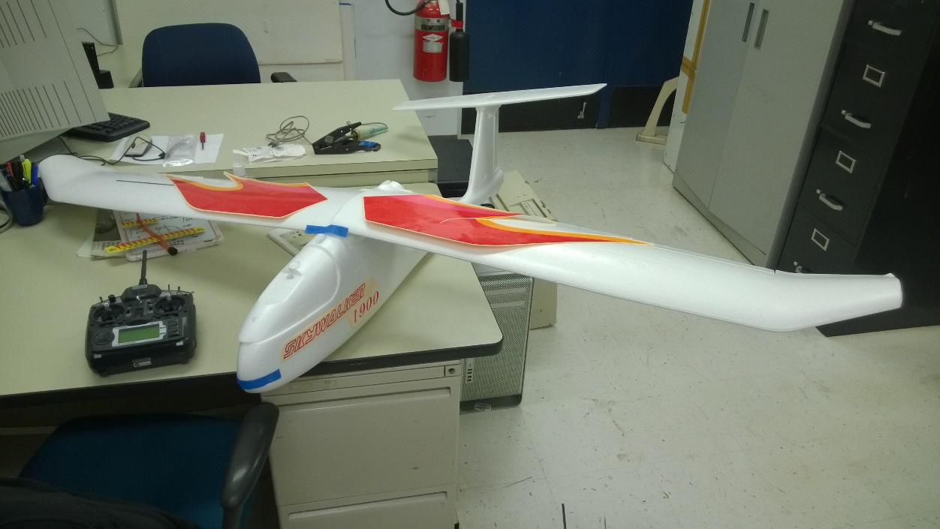

Figure : TEDD is equipped with a Sony Nex-5 downward facing camera for high-resolution digital imagery collection.

## Camera Operated Navigation Done Outside (GPS) Ranges (CONDOR)

The AFSL has developed a UAS platform for developing and validation visual-servoing algorithms specifically focused on aiding navigation and system performance in GPS-denied environments. This system is based on a Skywalker 1900 airframe with a modified Pix Hawk autopilot. The system contains an independently controlled pan/tilt/zoom camera with a real-time video and data link to a custom ground station.

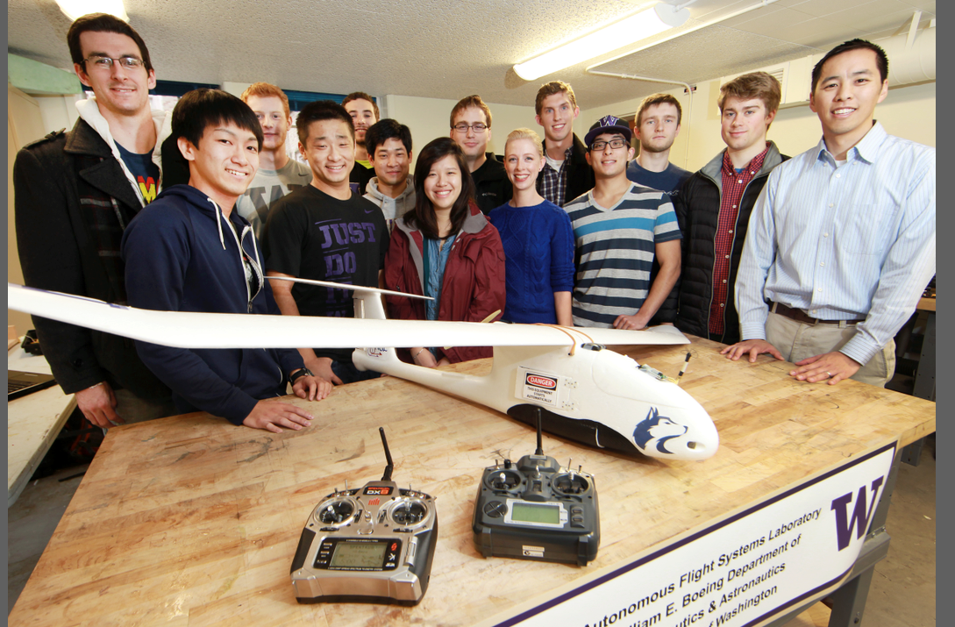

Figure : The AFSL CONDOR UAS for investigating vision-based control algorithms operating in GPS-denied environments.

## Miscellaneous Aircraft

In addition to the main UAS described above, the AFSL has several other aircraft systems for special purposes.

**ADD INFORMATION ABOUT THE DUBCUB**

|  |  |
| --- | --- |
| C:\Users\Christopher\AppData\Local\Microsoft\Windows\INetCache\Content.Word\WP_20140707_14_44_47_Pro.jpg | C:\Users\Christopher\AppData\Local\Microsoft\Windows\INetCache\Content.Word\WP_20140707_14_47_29_Pro.jpg |
| Figure : The AFSL solar powered UAS. | Figure : The YAK-54 is used for high performance control algorithm development and validation. |

# UAS Manufacturing and Testing Facilities

## University of Washington Aeronautical Laboratory (UWAL)

The AFSL has direct access to the University of Washington Aeronautical Laboratory ([UWAL](http://www.uwal.org/)) and conducts aerodynamic surveys and tests in this facility. The main facility is the Kirsten Wind Tunnel, a subsonic, closed circuit, double return wind tunnel. The tunnel has a test section with a rectangular 8' x 12' cross-section that is 10 feet long. The large test section allows many UAS to be tested at full scale (Figure 9). Two sets of 14' 9"-diameter seven-bladed propellers move the air up to 200 MPH through the test section. A computer-automated model positioning and data acquisition system ensures testing efficiency and precise measurements while a networked data reduction and plotting system allows for immediate data visibility. Most tests make use of UWAL's six-component external balance. UWAL also supports high channel count Electronic Pressure Scanning (EPS) systems.

A smaller, low speed 3’x3’ wind tunnel is also available for testing of smaller models (Figure 10).

|  |  |
| --- | --- |
| C:\Users\Christopher\AppData\Local\Microsoft\Windows\INetCache\Content.Word\uwal.jpg | C:\Users\Christopher\AppData\Local\Microsoft\Windows\INetCache\Content.Word\WP_20140707_14_34_09_Pro.jpg |
| Figure : Test section of the Kirsten Wind Tunnel | Figure : The low speed, 3’x3’ wind tunnel |

## UAS Manufacturing Lab

The Autonomous Flight Systems Laboratory has several facilities for manufacturing, maintenance, upgrading, and testing of UAS. This includes several hundred square feet of space as shown in Figure 11.

|  |  |
| --- | --- |
| C:\Users\Christopher\AppData\Local\Microsoft\Windows\INetCache\Content.Word\WP_20141205_12_00_22_Pro.jpg |  |

Figure : UAS manufacturing and maintenance facilities.

## Proprietary/Sensitive Software Development Secure Room

The AFSL has a secure room for developing ITAR sensitive or proprietary applications. This room has controlled access secured by two sets of locked doors. This room is not accessible to general AFSL members. A technology control plan for work performed in this room has been reviewed and approved by the UW.

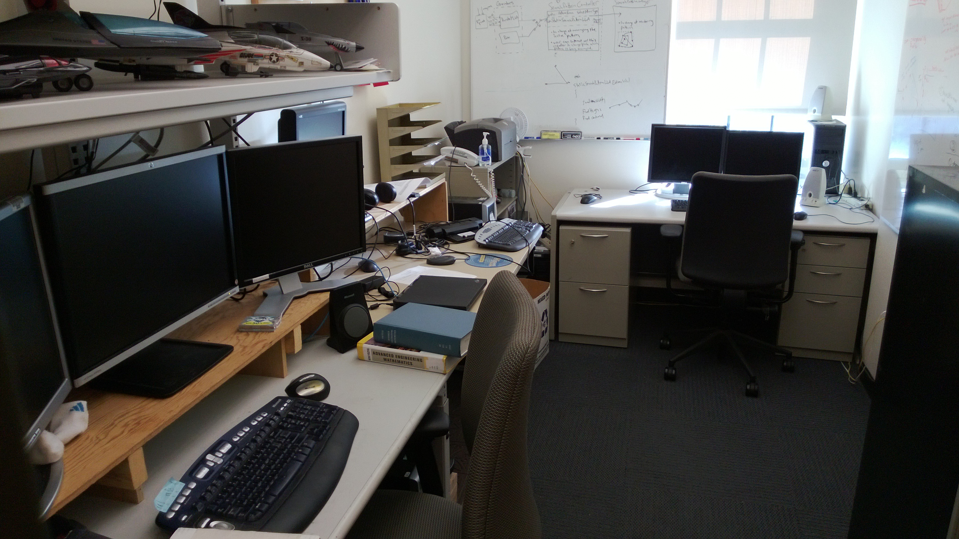

Figure : The AFSL secure development room which is used for proprietary or sensitive work.

# FAA Certificates of Authorizations (COAs)

The UW has several current COAs for operating and testing UAS operations. These include:

1. UAS COA 2013-WSA-144 Boardman, OR
2. UAS COA 2013- WSA -66 Columbia River , near Boardman
3. UAS COA 2014 – WSA- 22 Chinook Pass, WA

**ADD INFORMATINO ABOUT THE NEW COA WE ARE APPLYING FOR**